Flame Tests

Some element ions give a characteristic colour when placed into the flame of a Bunsen burner. These different colours can be used to identify different cations (positive ions).

Aims

To observe and compare the colours of flames produced by different elements.

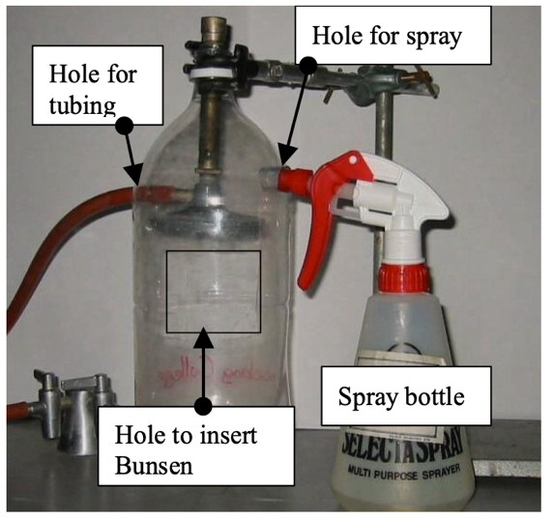Apparatus/Equipment

* Flame test bottle setup – shown in figure.
* Retort stand, boss head and clamp.
* Heat resistant mat
* Matches
* *Chemicals (*1M cation solutions (chloride or nitrate salts are best) made up with distilled.)

Potassium nitrate

Strontium nitrate

Copper(II) sulfate

Barium nitrate

Lithium nitrate

Risk Assessment

|  |  |
| --- | --- |
| What are the risks in doing this experiment? | How can you manage these risks to stay safe? |
| The Bunsen burner and equipment will get hot and could cause burns | Turn off the Bunsen burner or turn it to a yellow flame when not in use.  Handle hot objects with care and do not place them directly onto bench tops; use a heatproof mat. |
| Use of chemicals |  |

Procedure/Method

*Set up*

1. Set up a retort stand and clamp the neck of the bottle to hold it and the Bunsen assembly stable (see diagram above).
2. Place a blue heat proof mat under the bottle assembly.
3. Adjust the air intake valve of the Bunsen to the fully open position (to obtain a blue flame).

*Tests of Metal Solution*

1. Dim the lights in the laboratory.
2. Turn on gas and light Bunsen burner (with intake valve fully opened) using a match.
3. Spray (once or twice) the cation solution in the designated hole in the bottle – into the intake valve of the Bunsen whilst light.
4. Observer and record the colour of the cation (metal solution) flame.
5. Repeat for all cations.
6. Once complete rinse the bottle with tap water.

Results

Create a table of your results, showing the chemical name and the colour of the flame. Compare your results with those other groups because observation of colour can differ between individuals.

|  |  |
| --- | --- |
| **Substance** | **Dominant Colour** |
|  |  |
|  |  |
|  |  |
|  |  |
|  |  |
|  |  |
|  |  |

Questions

1. Based on a table of colours and metals – what might be the unknown metal solution?
2. Describe any patterns you can see in your results.
3. Describe any problems you had with determining the colours. Compare your results and observations with those of other groups.
4. Research the colours you should have seen for these elements. Your teacher may provide you with the expected colours.

Discussion

1. Explain why the same elements will have the same colour flame when a flame test is conducted.
2. Explain why you may not have seen the expected colours in this experiment.

Conclusion

Write a conclusion linking elements and their flame colours.